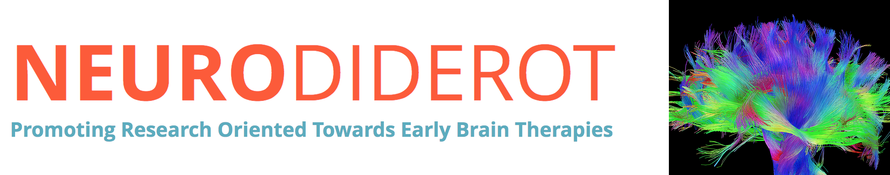

A Postdoctoral position is open in the Integrative genomics for neurodevelopment group at NeuroDiderot. We propose to carry out advanced systems genetics approaches to identify genetic drivers and new therapeutical options for epilepsy. This is to follow up on the paper in Genome Biology (Delahaye-Duriez et al. 2016, https://doi.org/10.1186/s13059-016-1097-7). The project is funded by ANR (https://anr.fr/Project-ANR-18-CE17-0009).

Further information can be found at the lab's website:
http://neurodiderot.org/index.php/en/delahaye-en/

The appointment is for 12 months initially, with a possible extension for another 12 months.

Profile requirements:
- Holding a degree in Statistical Genetics, Biostatistics, Computational Biology, Bioinformatics, Computer Science, or Mathematics
- Proficiency with at least one programming language (R and/or Python) and with bash/shell scripting
- Computational background to easily adapt to a UNIX environment in a high-computing cluster
- Experienced in analysing large-scale datasets
- Able to communicate effectively and to interact in interdisciplinary setting
- Flexibility to move between analytical and managerial work

Address applications to:
Andrée Delahaye-Duriez, MD, PhD
NeuroDiderot, Inserm UMR1141
https://www.neurodiderot.com/
Robert Debré hospital
48 boulevard Sérurier
75019 Paris
andree.delahaye@inserm.fr

